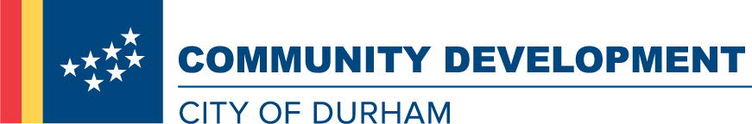
Position Description
Work, Serve, Thrive. With the City of Durham
Advance in your career while making a real difference in the community you serve.
The Community Development Department promotes thriving, livable neighborhoods in Durham. We work with lenders, developers, builders, community organizations and residents to enhance the quality and availability of affordable housing. We empower low-income and first-time home buyers to secure and remain in housing. Our talented, creative and committed staff make this happen. If you share our commitment to quality affordable housing, collaborative work and serving our community, join our team!
Hiring Range: $54,580.50 - $69,576.00
Temporary Full-time w/Benefits
Duration of Assignment: 42 months
The Senior Community Development Analyst for the Neighborhood Stabilization Team administers the U.S. Department of Housing and Urban Development (HUD) Lead-Based Paint Reduction and Healthy Homes Program for the Community Development Department. Responsibilities include supervising the Senior Code Enforcement Officer for the Lead Grant Program, developing annual program budgets and work plans, managing and overseeing the complaint/resolution process in accordance with program procedures, preparing and submitting required HUD reports, and managing marketing/outreach and application in-take. The Senior Community Development Analyst reports to the Community Development Manager for Neighborhood Stabilization in the Community Development Department.
Duties/Responsibilities
- Administers the federally-funded Lead-Based Paint Reduction and Healthy Homes Program. Includes preparation and submission of required HUD reports and day-to-day oversight of all aspects of program implementation.
- Supervises the Senior Code Enforcement Officer for the Lead Grant Program, develops and manages annual program budgets (including grant fund draws), and creates and implements work plans.
- Ensures that planned and in-progress lead-funded jobs are compliant with federal, state, and local program guidelines, including Housing Rehabilitation and Lead Safe Housing regulations, Davis-Bacon wage requirements, and federal Section-3 regulations.
- Establishes and maintains working relationships with grant partners and monitors the contractual obligations and performance of grant partners.
- Oversees maintenance of the Lead Grant Program database and accuracy of database generated reports.
- Makes presentations to the general public about lead paint issues and other applicable topics.
- Performs all duties listed in the position description as well as other related duties as assigned.
Minimum Qualifications & Experience
- Bachelor's degree in business or public administration or related field
- Five years of professional program administration working with a local, state, or federal grant program
- Supervisory experience
- NC Class C Driver's license
Additional Preferred Skills
- Experience working with a HUD Lead-Based Paint Grant Program.
- Excellent customer service skills and demonstrates ability to work in diverse communities with a variety of community residents.
- Strong oral and written communication skills. Must be able to write clear, concise plans and reports and make excellent public presentations.
- Strong organization skills.
- Must be able to handle multiple tasks and meet program goals and deadlines.
- Excellent computer skills, including competency in use of Microsoft Word, Excel, and PowerPoint.
- Knowledge and/or experience with Davis Bacon and Section 3 federal regulations
Agency
City of Durham
Address
101 City Hall Plaza
Durham, North Carolina, 27701
Website
http://agency.governmentjobs.com/durhamnc

